To see the project in working follow the below steps:

1.Open the folder named "code"

2.Open the file named "app.py" using 'visual studio code'.

3.Press f5 and then the following options should appear: 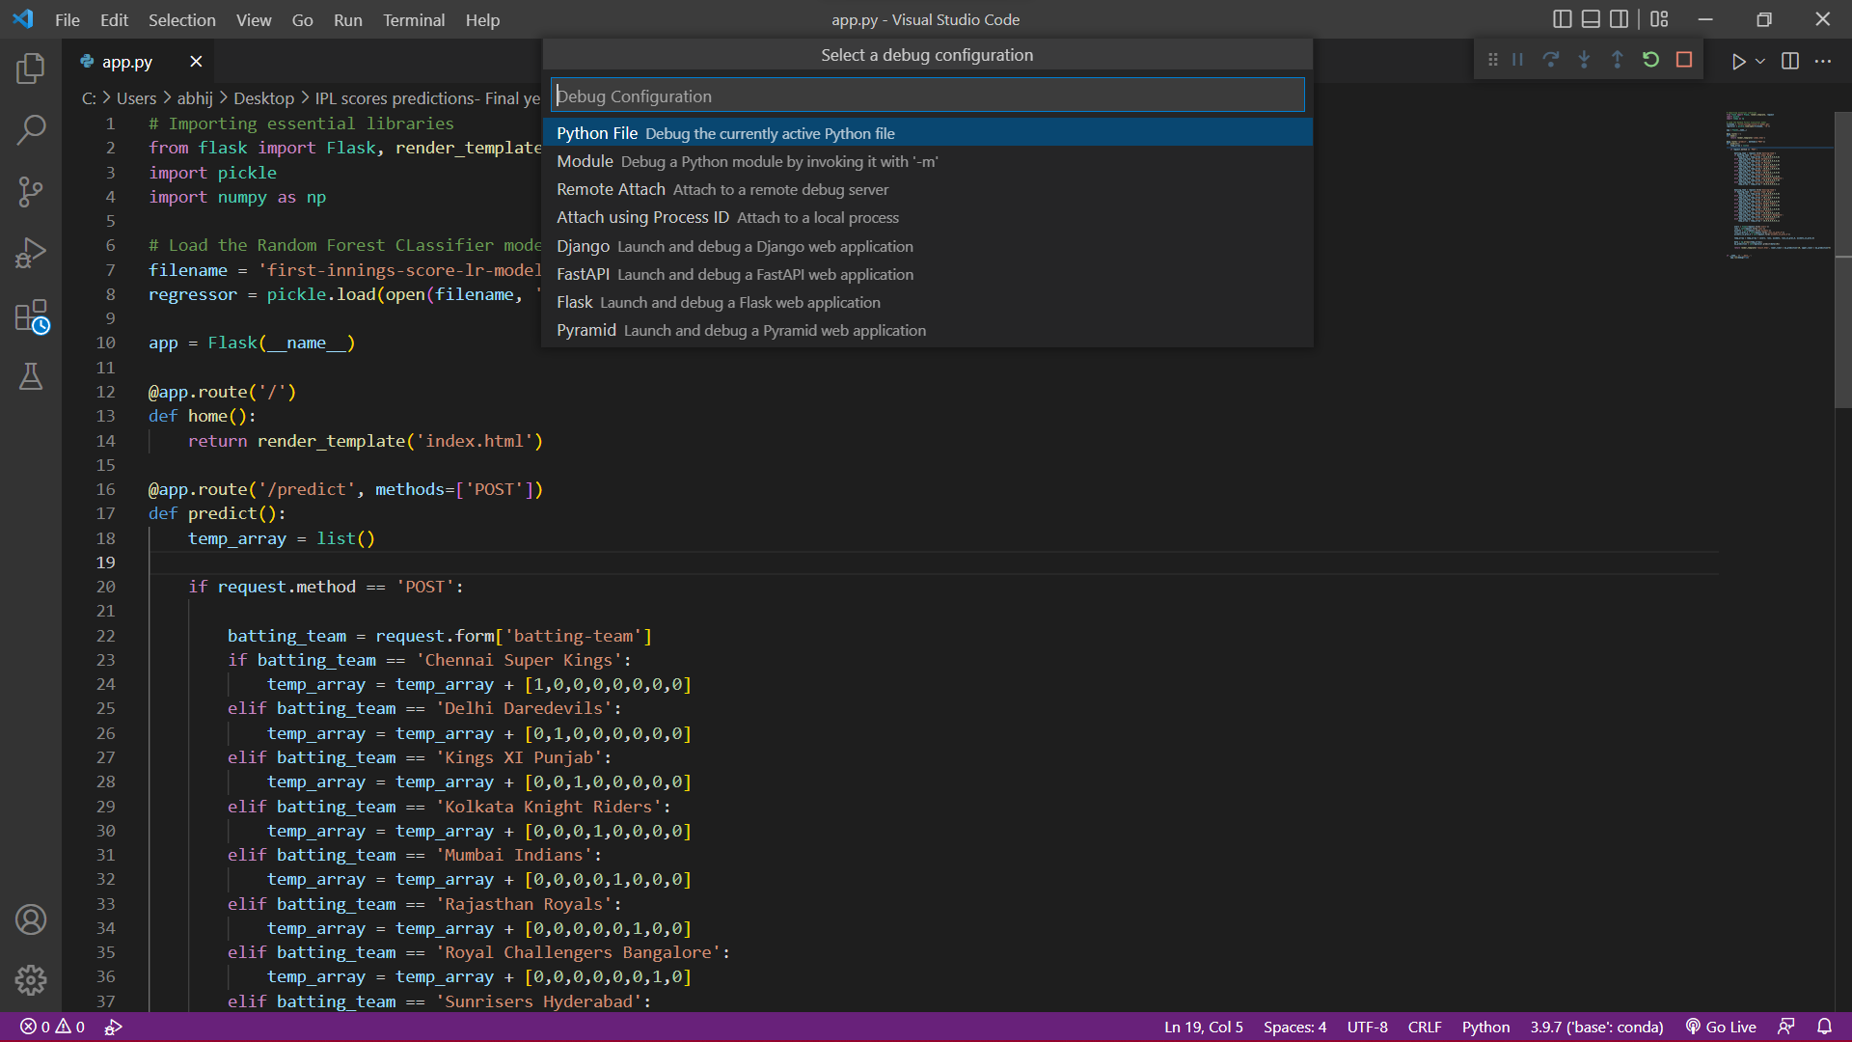

4.Press enter to select the python option. Then the following screen should appear:

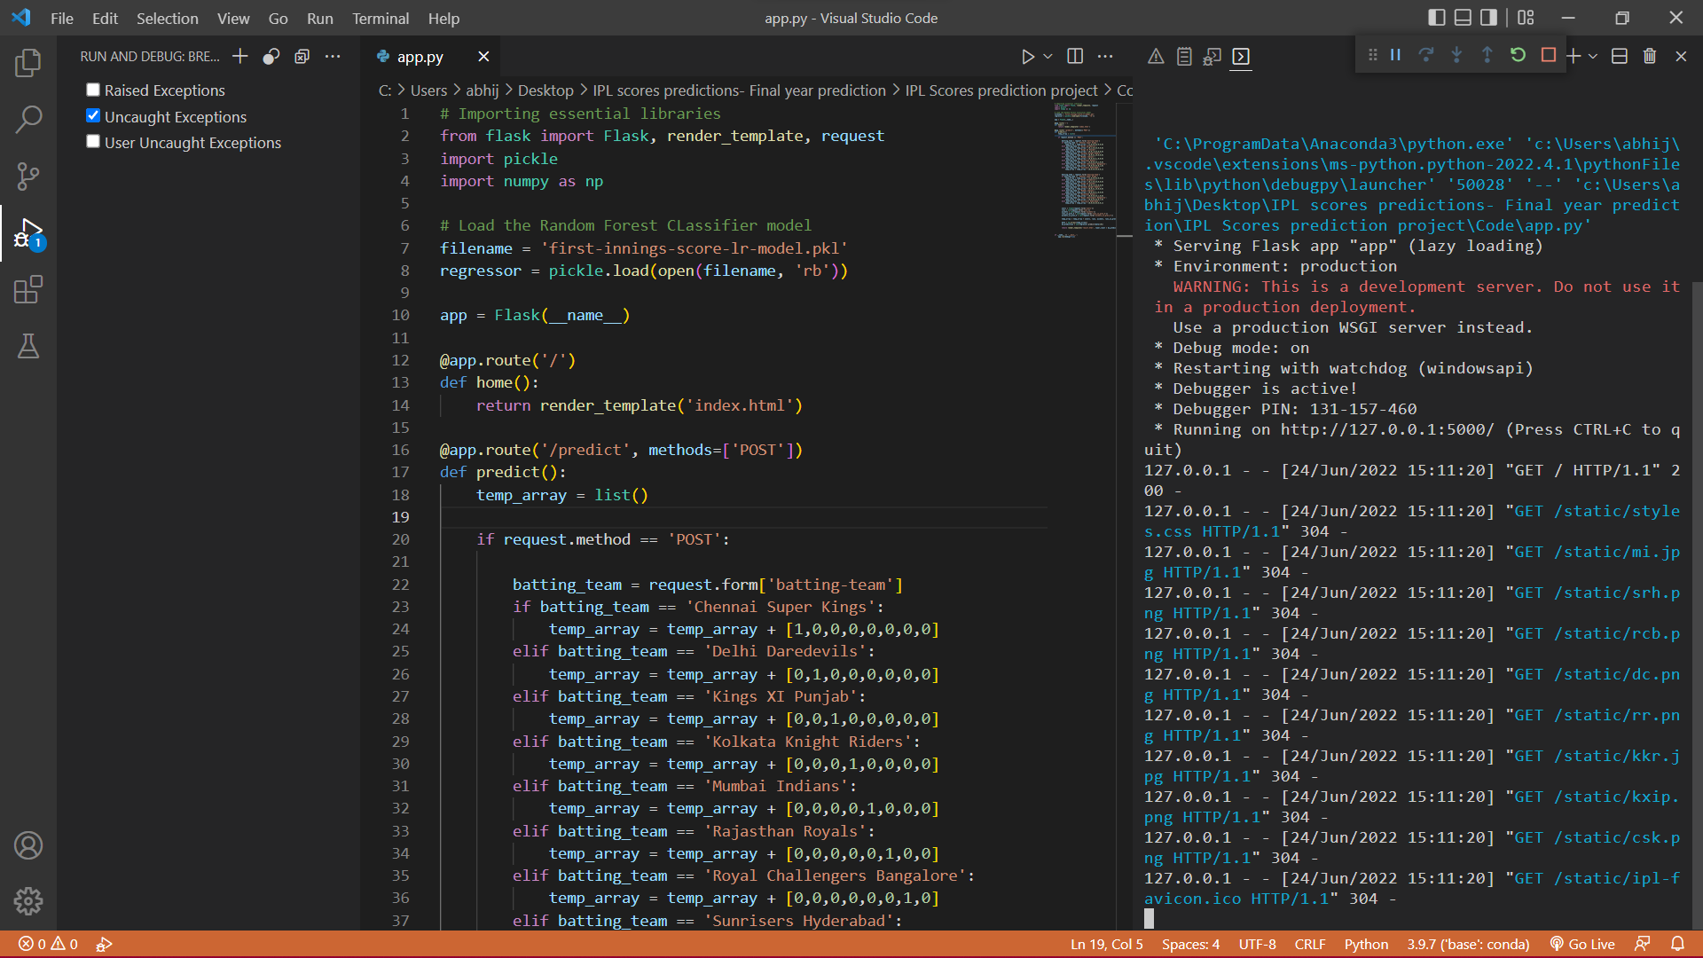

5.Ctrl+Click on the link <http://127.0.0.1:5000/> that appears on the right-hand side in the VS Code.

6.The link should open in a browser and the webapp is visible. Use the webapp by filling in all the asked details and get score predictions.

